

Resilient Roots

Mentor Handbook
February 2025

This guidance is based on the mentoring handbook produced for the National Lottery Communities Fund Energy Learning Network, which in turn was informed by guidance produced by CAG Consultants and Co-operatives UK; we are grateful to them for allowing us to base this handbook on their guidance.

Contents
1 INTRODUCTION 5
1.1 Who are Ashden? 5
1.2 What is Resilient Roots? 5
1.3 About the Resilient Roots peer mentors and mentees 6
1.4 Who is running this mentoring programme? 7
1.5 Who are the Mentees? 7
1.6 Who are the Mentors? 7
1.7 Benefits for our Mentors 7
2 HOW IT WILL WORK 8
2.1 Matching mentors to mentees 8
2.2 Format and time commitment 8
2.3 Fees and payment 8
2.4 Reporting 9
2.5 Travel expenses 9
2.6 Evaluation and programme learning 9
3 Code of Conduct 9
3.1 Professional Conduct and Quality Assurance. 9
3.2 Recognising equity and diversity 10
4 WAYS OF WORKING 10
4.1 Establishing a successful relationship with your mentee 10
4.2 Confidentiality 10
4.3 Early termination of the agreement 11
5 TOOLS AND TECHNIQUES 11
5.1 20 key questions 11
5.2 Goal setting and action planning 12
5.3 The GROW Model 12
5.4 Will / Way forward 14
5.5 Flexibility of GROW 14
5.6 SWOT Analysis 14
5.7 G-STAR model 15

INTRODUCTION
The Mentor Handbook is a guide for those who would like to provide paid mentoring support for local authorities and community groups based in the North West of England who are keen to develop and deliver nature-based solutions to climate impacts.

Ashden Climate Solutions (Ashden) has received funding from the Lund Trust to deliver the Resilient Roots programme (see below). As part of the programme, Ashden are managing a peer mentoring support service where mentees can be matched with expert mentors willing to provide 3 days mentoring support, paid at a rate of £300 per day (incl. of VAT). The Handbook sets out how the Resilient Roots mentoring programme is delivered, the processes involved as well as offering useful tips and guidance in delivering mentoring support.

In addition to this handbook, Mentors will also be asked to sign a short contract which outlines that all mentors remain an independent contractor and not a direct employee of Ashden.

This is a living document, and we welcome your contributions to improve the content. Please contact Matthew Ahluwalia at Ashden for more information: matthew.ahluwalia@ashden.com

Who are Ashden?
Ashden are a climate solutions charity working in the UK and the Global South. Our mission is to accelerate transformative climate solutions and build a more just world. For 25 years we have done this through the Ashden Awards, an annual celebration of climate innovators. In the UK, Ashden also supports local authorities and community organisations to deliver locally-led climate projects that also boost health, social connection and the green jobs of the future.

What is Resilient Roots?
Funded by the Lund Trust, in 2025 Ashden will run a pilot project in the North West to build the knowledge and capability of local organisations – public, private and third sector – to deliver nature-based solutions to climate impacts like flooding and extreme heat. These nature-based solutions might include sustainable urban drainage systems (SuDS), restoring urban parks and wetlands or strategic tree planting.
Why?
- Councils and community groups are well-placed to deliver grassroots nature-based solutions. However, lack of knowledge is a barrier to implementation, as is a lack of connection to peers in the region facing the same challenges. There is also a disconnect between local and national policies pertaining to nature-based solutions.
How?
- A series of four workshops will be delivered to drill down into challenges affecting progress, share good practice, and build useful connections between attendees. The in-depth exploration of barriers and good practice will help to inform regional level plans to strengthen nature-based adaptation.
- A peer-to-peer mentoring programme will be delivered, supporting 12 community organisations in the region to work effectively with the local authority to deliver place-based adaptation initiatives. Mentors will be drawn from past Ashden Award applicants such as Thames 21, Wild Haweswater and Trees for Streets.
- As insights emerge over the course of the project, Ashden will coordinate policy asks and messaging that reflect the needs of the councils, charities, and voluntary organisations we have engaged through the workshop series. These messages will, in turn, be targeted at local, regional and national policymakers.

About the Resilient Roots peer mentors and mentees
The peer mentors are individuals who have expertise in a particular area – whether topic-based (such as SuDS, restoring urban parks and wetlands or strategic tree planting) or process-based (such as engaging diverse audiences or communicating with younger audiences). All those with expertise relevant to nature-based solutions and a desire to provide mentoring support can apply to be Resilient Roots peer mentors.

The peer mentees will be from community groups or local authorities within the North West of England.

In this context, the term ‘mentoring’ describes a relationship in which an individual or organisation (via the key people in it) is supported through a learning or developmental journey. It’s about reflecting, encouraging and supporting the new or existing project to make the most of its potential.

Mentoring is part of a spectrum of organisational support, which includes providing advice and coaching. Because the mentees will have different needs, and because the support provided through this programme is short-term, it is likely to include elements of providing advice and coaching. This is not a problem, but it is helpful for a mentor in the programme to be aware of the type of support they are providing. It is also important that you are clear on the qualifications and limitations of any advice you are providing where you have not been contracted by the individual to provide specific advice, and instead are offering mentoring support. The table below shows the commonly understood differences between the three types of support.

Table 1 – types of support
 | Adviser | Coach | Mentor
Focus of the role | Guiding | Task and performance, building skills and competence | Building capability
Key skills required | Imparting own experience and wisdom | Give feedback on performance | Helping mentees discover their own knowledge and experience
Goal orientation | Helps align individual and organisational goals | Helps coachee establish personal goals | Usually works with mentee’s own goals
Closeness of relationship | Low- moderate | Moderate | Relatively high, can lead to a strong friendship
Flow of learning | Mainly one-way | Mainly one-way | Usually two-way

Who is running this mentoring programme?
The Resilient Roots Peer Mentoring programme is managed by Ashden.

Who are the Mentees?
Any local authority, community group or not-for-profit organisation based in the North West that is looking to act on nature-based solutions can receive mentoring support subject to availability. We have funding to provide support for up to 12 mentees.

It is anticipated that each mentor will generally work with an individual, or with a small group from within the same organisation, by agreement and where this is deemed suitable.

Who are the Mentors?
All those with expertise relevant to nature-based solutions and a desire to provide mentoring support can apply to be a Resilient Roots peer mentor.

Mentoring opportunities will be allocated by Ashden on a case-by-case basis based on identified need and potential alignment with mentor skill set. Applying to be a mentor does not guarantee mentoring opportunities will be available.

Benefits for our Mentors
Delivering nature-based solutions can be a challenge. Even with the right group of people in place, there will always be unknown issues and challenges ahead. Meeting those involved in delivering nature-based solutions through peer mentoring is a learning opportunity for both parties. Mentors are facilitators/convenors and are able to widen/test knowledge and understanding.
Mentoring is a two-way process and can be as beneficial to the mentor as it is to the mentee. As well as receiving some financial support for the time you put in, here are some more reasons to get involved:
- We hope that this programme will inspire and motivate mentors to develop their potential and unleash the best in themselves.
- It will provide a chance for mentors to step outside of the day-to-day environment and use their professional skills in an entirely new and rewarding context.
- It enhances interpersonal, communication and mentoring skills and the transfer of these skills back into the workplace.
- It should deliver a rewarding sense of job satisfaction and energy from helping a mentee develop and grow their climate action project.
- Mentors can find they expand their personal communication skills, developing their understanding of learning styles and how to share knowledge by asking the right questions, in an appropriate and open manner.
- Mentors will realise they have huge amounts of tactical (practical) experience, and many find it extremely rewarding to support other people wherever they can.
- Peer mentoring can be used as part of continuous professional development (CPD). Mentors develop new skills and perspectives from the mentee through “reverse mentoring”.

HOW IT WILL WORK

Matching mentors to mentees
Ashden will coordinate the process of matching mentors to mentees. This will involve:
- Firstly asking mentees to provide specific information about the type of support they need. This will include what the issues are that require support, broadly whether it is topic or process based, and who the mentees will be (individual or small team).
- Inviting mentors to indicate which mentees they think they could offer useful support to.
- Sharing mentor information with mentees along with a suggestion of an appropriate mentor and inviting the mentee to accept the recommendation or request a different mentor.
- Ashden will then inform mentor and mentee that they should go ahead and set up an initial meeting to discuss how the mentoring will be delivered.
- Following that initial meeting, Ashden will check with the mentee that they are happy to continue and will then give both parties the go ahead.
Where the mentoring is topic based, it is likely that the mentee will be seeking advice from a mentor who has practical experience of that topic.
Where the mentoring is more process based and is for an individual it is likely the mentee will be needing more coaching support in specific areas such as team leadership, project management and partnership working.
Where the mentoring is more process based, and for a team, it is likely that the team will need more partnership or team development support.

Format and time commitment
Mentors will be responsible for co-ordinating and leading the sessions which will focus on the needs identified through the match-making process.

Up to three days of peer mentoring support (includes induction training – see below) will be given per organisation being mentored. The pace, number and length of sessions will be flexible and led by the mentee. It will be up to the mentor and mentee to consider whether this be by phone, video conferencing and email, or face to face.

Fees and payment
The day rate for provision of peer mentoring support is £300 (incl. VAT) per day for 7 hours of support. Up to three days of peer mentoring support will be given with sessions taking place between May and November 2025.
Mentors should use 0.25 days of the funded support for reporting and induction training provided by Ashden.
Once the mentoring support has been approved, a payment of £900 will be made to the mentor’s host organisation. Those mentors looking to be paid as an individual will require separate agreement with Ashden. Before payment is made, organisations will need to get set up as a supplier on the Ashden system.

Reporting
When the mentoring support has been completed, the mentor should inform Ashden. The mentor and mentee will be asked to complete a short feedback report. This is an opportunity to advise how the support was delivered, what went well, what could have been better and the impact of the support. The report will be stored securely by Ashden. Ashden will use the information to report on the outcome of the programme and will ensure that individual organisations are not identifiable in the report.

Travel expenses
Unfortunately, we are unable to pay additional fees for any travel expenses or other expenses. These will need to be provided for within the fee listed above. (We anticipate that the majority of the mentoring will be provided through online meetings.)

Evaluation and programme learning
At the end of the mentoring sessions we expect that some groups may wish to continue to learn and collaborate. We will ask for feedback from mentors and mentees so that we can further refine, scale and develop the programme and establish how it might be continued in the medium-term if there is demand.

Code of Conduct

Professional Conduct and Quality Assurance.
By taking on the role the Mentor agrees to adhere to our professional standards and specific terms and conditions and will take steps to avoid any conflicts of interest.
We abide by The Global Code of Ethics For Coaches, Mentors, and Supervisors. By taking on this role, the mentor agrees:
- To act in a professional way at all times, providing consistently high quality, responsive and timely support to the mentees.
- Ensure transparency and open communication with Ashden.
- To not exploit a mentee or seek to gain any inappropriate financial or non-financial advantage from the mentoring relationship. If a mentee asks a mentor to deliver further support outside of the scope of work agreed under the Resilient Roots Peer Mentoring programme, we expect mentors to inform Ashden and to provide details of the support being requested / supplied. (This is because if any issues/complaints arise as a direct result of work carried out by the Mentor without prior knowledge or agreement with Ashden, this could create a reputational risk for Ashden).
- To be aware of the potential for conflicts of interest of either a commercial or personal nature arising through the working relationship and address them quickly and effectively in order to ensure that there is no detriment to the mentee.
- To alert Ashden to any issues / concerns with a mentee particularly where this could affect their ability to deliver aims, objectives and milestones.
- To respond to complaints / issues / feedback immediately and alert Ashden accordingly.
- To submit a final feedback report to Ashden using the template that we will provide.
As part of our quality assurance processes, we will invite each mentee to comment on the support provided at the end of the programme.

Recognising equity and diversity
- Mentors will abide by their respective bodies’ diversity statements and policies.
- Mentors will avoid knowingly discriminating on any grounds and will seek to enhance their own awareness of possible areas of discrimination.
- Mentors will be cognisant of the potential for unconscious bias and seek to ensure they take a respectful and inclusive approach, which embraces and explores individual difference.
- Mentors will challenge in a supportive way any colleagues, employees, service providers, mentees or participants who are perceived to be using discriminatory behaviour.
- Mentors will monitor their spoken, written and non-verbal communication for inadvertent discrimination.
- Mentors will engage in developmental activities that are likely to increase their self- awareness in relation to equality and diversity.

WAYS OF WORKING

Establishing a successful relationship with your mentee
Your mentee may be one or more individuals from one organisation. Once you have been matched, we suggest that you:
- Introduce yourself
- You may wish to organise an initial video call with all your mentee so they can confirm their starting points and the support they are looking for.
- Agree how the mentoring support will be delivered, methods of communication and pace of meetings and how often, noting that these will be delivered remotely. Establish a set of ground rules.
- Use your questioning and listening skills to establish your mentee’s goals and objectives.
- Mentoring is usually on a one-to-one basis. If there is more than one mentee from the organisation, please consider group dynamics and use your facilitation skills to ensure that each person has an equal opportunity to speak and avoid one person dominating conversations. Consider offering a variety of group and 1 to 1 sessions to allow different personality times to gain value from the sessions.
- Keep notes of your meetings and use these as the basis for ongoing discussions. Remember to capture any specific issues or learning that can be used by the programme. This is also important when we ask for your feedback and for evaluation purposes.
- Work towards developing a trusting relationship and establishing a good rapport with your mentees.

Confidentiality
It’s really important that you respect each other’s confidentiality. Remember that anything you talk about when you meet up is between you and the mentee and you shouldn’t talk about it to someone else. But you should report any criminal conduct, possible harassment or bullying.
Four things to think about are:
- Concerns. If you’ve got any, contact Matthew Ahluwalia who is managing this mentoring programme at Ashden; he’ll be happy to help. matthew.ahluwalia@ashden.org
- Secrets. Don’t promise to keep any secrets. Make that clear from the beginning and remember to ask your mentee if they mind you sharing confidential information with anyone else.
- Information. Keep information about your mentee (like their phone number) somewhere secure. Never share any of their financial details.
- You. Confidentiality works both ways. Be aware of those personal areas of your life you’re happy to share with your mentee and those you are not.

Early termination of the agreement
Although every effort will be made to ensure a close match between you and your mentee(s) sometimes this may still not work out. This may be no reflection on either party, and either party may finish the relationship, and exit the agreement.
If any issues arise during the programme, you should contact Matt Ahluwalia at Ashden as soon as possible and every effort will be made to address any issues. Both parties will be contacted to confirm the situation and offer support if required. Another suitable Mentor/mentee may be arranged for both parties going forward.
Let Matt know when you’ve arranged your last session so that we can arrange a final review of both you and your mentee’s experience.

TOOLS AND TECHNIQUES
This section includes some tools and concepts that either mentors or mentees may find useful in their work together.

20 key questions
Here are 20 key questions that maybe useful to ask in your meetings with your mentee.
- “What will give you the most value from today’s session?”
- “What do you want to focus on today?”
- “What is keeping you awake at night?”
- “What is the present situation in detail?”
- “What is happening now that is working well?”
- “What is happening now that tells you that you have a problem?”
- “What do you have control over?”
- “What strengths and resources do you bring to this?”
- “Where do you want to be a year from now? How will you measure your success?”
- “If you had to find a way, what would it be?”
- “What do you not know about this situation/project? How could you find out?”
- “If you improved one thing you do, what change would make the biggest improvement to your organisation’s performance?”
- “What would you do if you knew you couldn’t fail?”
- “What do you enjoy about what you do?”
- “What might you be overlooking?”
- “Who else has done this before?”
- “What have you learned from this?”
- “What can you do differently next time?”
- “What did you do well?”
- “What will you do next?”

Goal setting and action planning
A great way to start is by setting goals and making an action plan. This will keep you on track and help you to:
- Find out where your mentee and their project need support
- Agree goals that they can work towards
- Gauge how you are doing and keep an eye on your goals
- Pat each other on the back for your successes
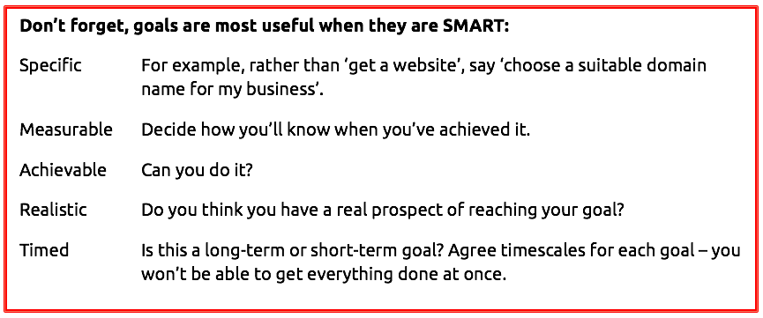

The GROW Model
Whilst this model is based on coaching, it can also be adapted for mentoring. It is usually more suited to individual one-to-one mentoring.
The GROW model was developed by Sir John Whitmore (1937-2017) in conjunction with colleagues in the 1980s and disseminated through his book ‘Coaching for Performance’ (Whitmore 2019), first published in 1992 and now in its 25th edition having been translated into 20 languages. GROW provides a framework for a coaching session, a conversation, a meeting or a project and is the best-known coaching model in the world today:
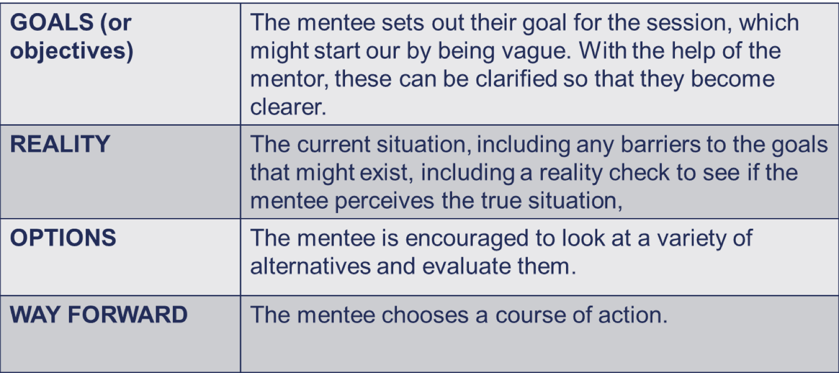
The GROW sequence illustrates the solution focus of coaching and breaks down like this:

Goal:
The Goal section of GROW is addressed at the beginning of each session and referred to again from time to time to keep the focus moving forward, especially if the mentee becomes stuck. It raises energy and clarifies thinking. Identifying what we want to achieve puts us on the path to accomplishing it by focusing on the solution rather than the problem.

Some Goal questions are:
- What do you want?
- Over what time frame?
- Where would you like to be on a scale of 1–10?
- Imagine you have achieved it:
- What do you want to achieve in five years/one year/three months?
- How could you say your goal in a few words?
- Which part of that is the real focus?
Reality:
This is an exploration of the mentee’s world at the moment. Time spent here helps people get clear about what is happening and how it affects themselves and others. It provides an opportunity for viewing issues from different perspectives.

Some useful questions here are:
- What is happening at the moment?
- How important is this to you?
- If an ideal situation is 10, what number are you at now?
- What have you done so far?
- What are you doing that’s working towards your goal?
- What are you doing that is getting in the way of your goal?
Options
Mentees will move naturally towards the Options stage as their Reality becomes clearer. Then it is useful to ask some of these questions:

- What are your options?
- What could you do?
- What else?
- What steps could you take?
- Who could help you with this?
- Where could you find out the information?
Notice that almost all of these questions are open. Keep asking open questions until the mentee has stopped coming up with options on the table. Once it seems that the list is complete, ask the closed question ‘is there anything else?’ to find out whether it is time to finalise the process. This question often results in new options and can be asked as many times as it continues to deliver results.

Will / Way forward
As opposed to ‘Options’, which brings to light all possibilities, ‘Will’ is about discovering which actions the mentee can commit to undertaking. When asked, ‘What will you do about this?’ there is a danger that the mentee will make a list of what they think they should do, rather than choosing a pathway which suits their talents and ways of behaviour.

Some examples of Will questions are:

- What will you do about that?
- How will you do that?
- When?
- What will it take for you to commit to that action?
- Where will you find that?
- Who will you talk to?
- What else could you do?
If the coach senses a lack of commitment, a question like, ‘How committed are you to doing that?’ should be asked straight away. If there is any hesitation, it is best to go back into the GROW process to clear any blocks and find the most comfortable way forward.

Flexibility of GROW
It is crucial to understand that the components of GROW do not necessarily follow that order; an effective coaching conversation usually starts by exploring Goal and Reality, but then moves about between all four elements.

SWOT Analysis
This is a useful technique for understanding the organisation’s strengths and weaknesses, and identifying opportunities and threats. It is a framework that your mentee can use to analyse themselves and can help them to craft a strategy that will help towards success.
Strengths | Weaknesses
Opportunities | Threats
The following questions can help you to guide your mentee to complete the SWOT grid for their own project.

Strengths
- What advantages does your project have over competitors?
- What do you do better than anyone else?
- What unique or lowest-cost resources can you draw upon that others can’t?
- What is the level of community support?
- What expertise does your team bring to the table?
Weaknesses
- What could you improve?
- What should you avoid?
- What are people in your market likely to see as weaknesses?
Opportunities
- What good opportunities can you spot?
- What interesting trends are you aware of? (Useful opportunities can come from such things as local events or changes in technology, markets, government policy, social patterns, population profiles and lifestyle changes.)
Threats
- What obstacles do you face?
- What are your competitors doing?
- Are quality standards or specifications for your job, products or services changing?
- Do you have bad debt or cash-flow problems?
- Could any of your weaknesses seriously threaten your business?
Encourage your mentee to think widely and creatively with their SWOT. Could any threats become opportunities, for example?

G-STAR model
This is a particularly useful technique to help your mentee think about a particular issue – it can often be a fast track to the real answers your mentee is looking for.

G What are your project GOALS?
- What are your goals for today’s discussion?
- What will give you the most value from today’s session?
- Do you have control over this issue?
- When do you need to achieve this goal by?
S What SITUATION is your project facing?
- How do you feel about the situation?
- How can you describe the situation?
- What do you know about the current situation?
- What do you not know about the current situation?
T What is their THINKING at this time?
- What options have you considered about the situation?
- What underlying assumptions are you making?
- Think how others would solve this problem.
- Think about how you will measure your success.
A What ACTIONS are they considering?
- What do you need to do first?
- By when do you need to have this done?
- In what sequence will you do these tasks?
- Can you think of anything that may disrupt your actions?
R What RESULTS do they expect?
- Are the results realistic?
- Have you considered other outcomes?
- What contingencies can you put in place?
- What are the consequences of not achieving these results?

